**The world and the machine**

The model proposed by M. Kackson & P. Zave, “The World & the Machine”, allow us to analyze the domain of MyTaxyService application and its relation with the world. This model contemplate the presence of two areas: *The Machine*, which is the portion of the system to be developed, and *The World*, which is the portion of the environment that is affected by the machine and not directly observable by the system. The intersection of the two is called *Shared Phenomena* and is composed by all the entities that are controller by only The World or The Machine, and observed by the other.

The following diagram shows MyTaxiService’s *The World and The Machine* analysis.

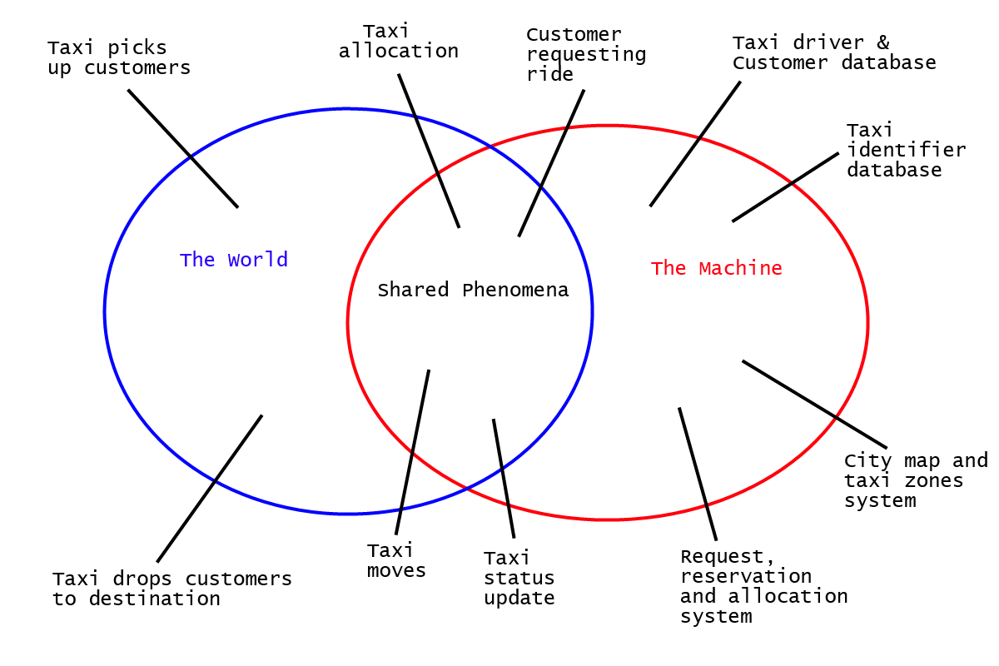

**Entities analysis:**

**The world**

“Taxi picks up customers” and “taxi drops customer to destination” are the only two phenomena that happen exclusively in the world. In fact, the machine can observe them only indirectly by monitoring the status of the taxi and its position.

**The Machine**

The machine is composed by the “Request, reservation and allocation system” which manages the main application logic, and is strictly dependent upon the “City map and taxi zones system”, the “Taxi identifier database” and the “Users database” entities.

**The Shared Phenomena**

“Taxi moves” is a shared phenomenon, which is controlled by the world and observed by the machine through the GPS system. “Taxi status update” is also a phenomenon controlled by the world (i.e. the taxi driver) and observed by the system.

“Taxi allocation” is observed by the world and controlled by the machine, which sets the taxi’s next destination accordingly to the customer requests. Instead, “Customer requesting ride” happens in the world and is only observed by the machine.